Vijay Electronic Store Information

EDA (Exploratory Data Analysis) Project
- Understanding the Problems/Dataset
This dataset consists of four interconnected CSV files representing an e-commerce business system. The data includes customer information, product details, order records, and order item transactions. Together, these datasets help analysis customer behaviour, product sales, order patterns, payment methods, and overall business performance.
- Importing necessary libraries
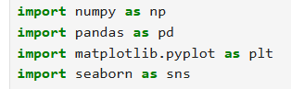
- Load the Dataset
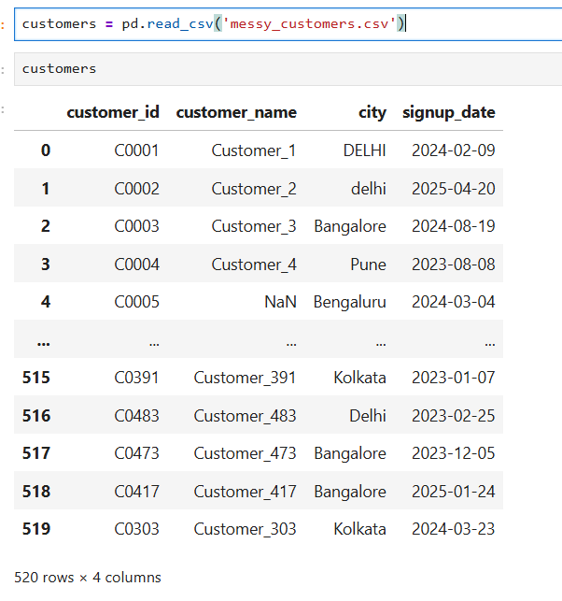
Observation: The customer table has 520 customers with unique ID, name, city, and their signup date.

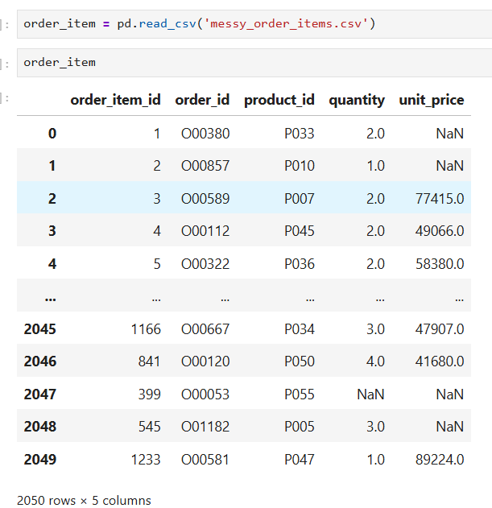

Observation: The order item table has the data of order item id, order id, product id, quantity sold and per order price.

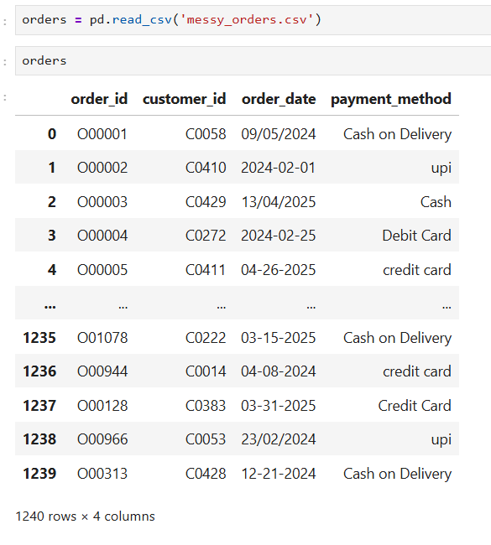
Observation: The orders table have 1240 orders with their order id, customer id, order date, and payment mode.

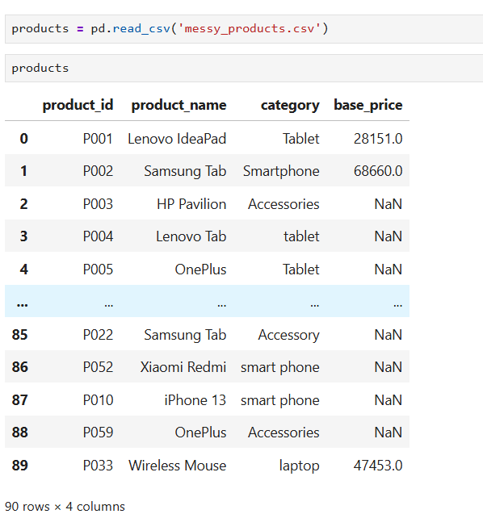

Observation: The product table consist of columns like product id, product name, category, and their base price.

- Data Info:
To look up for the basic structured of the dataset

- Customers Table

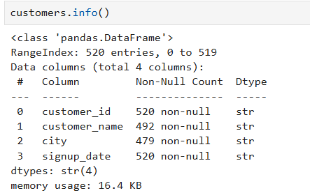

- Order Item Table

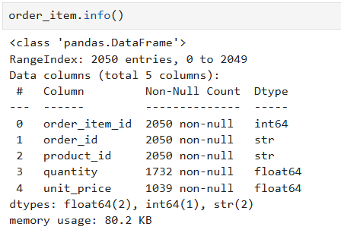

- Orders Table

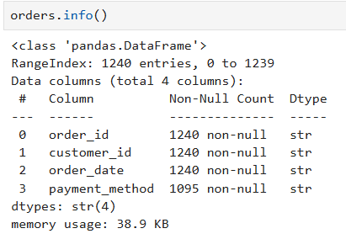

- Products Table

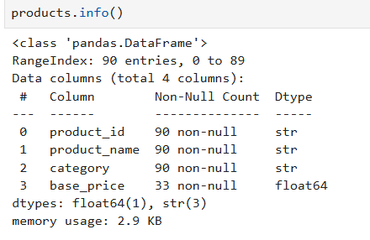

- Check Duplicates Values

- Customer Table

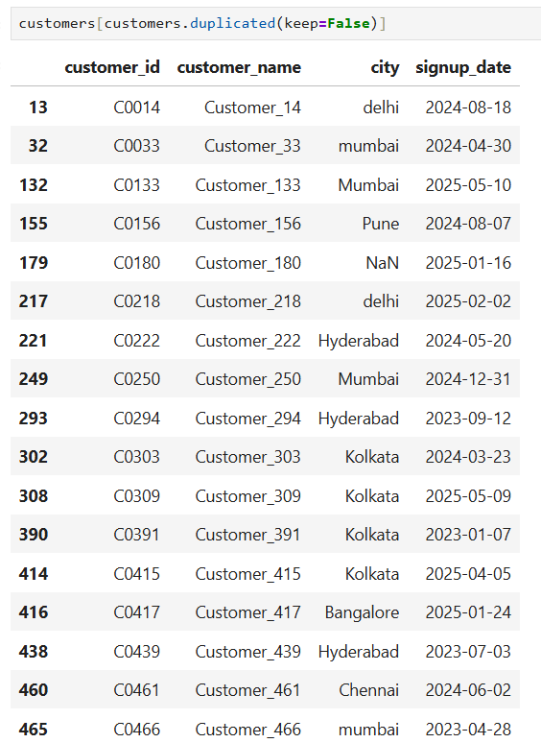

- Order Item Table
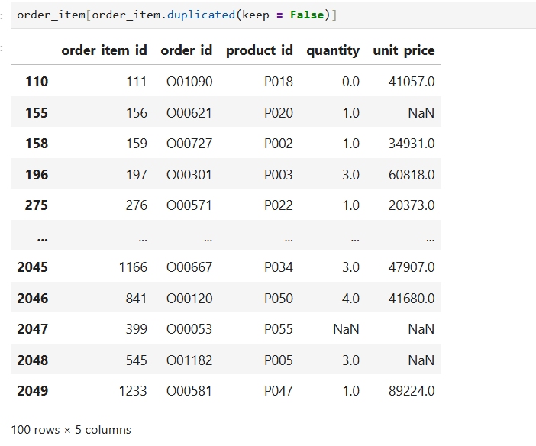
- Orders Table
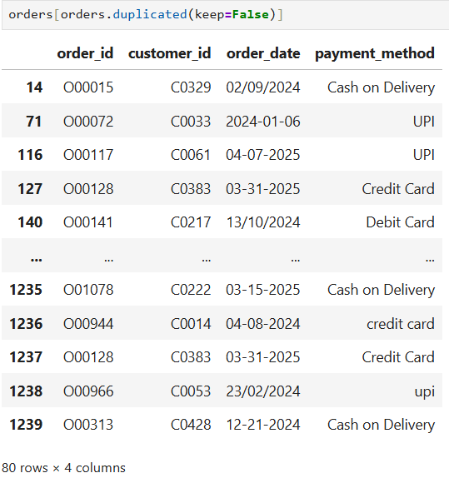

- Product Table

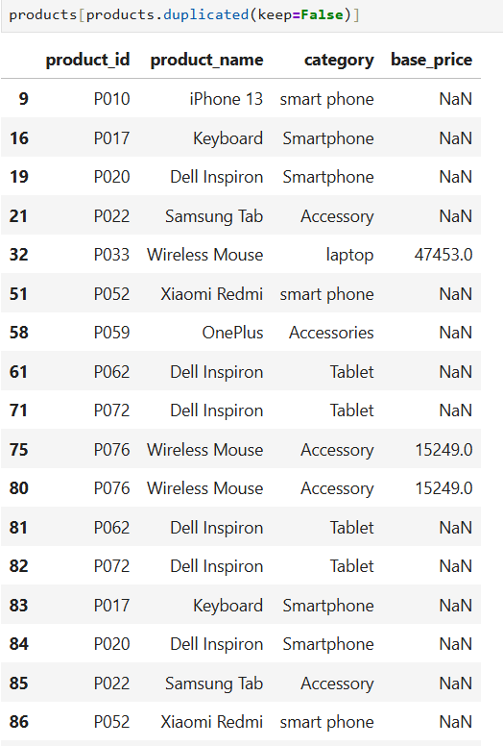

- Missing Values Check

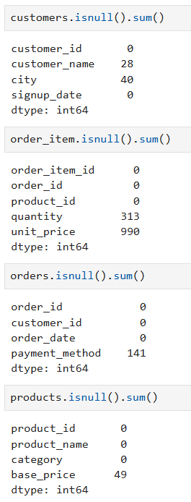

Observation:
- The customer table has null values in the customers name and city columns.
- The order item has maximum null values in base price columns.
- In orders table only payment method column has null values.
- The base price column in products table has null values.

- Pre-processing of data

- Removing the duplicates values from data

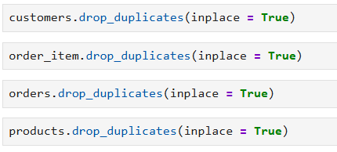

- Change the data type of column

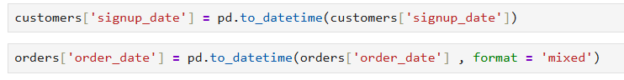

Observation: The column signup date and order date is converted into panda data time format for better understandings.

- Handling the inconsistent data
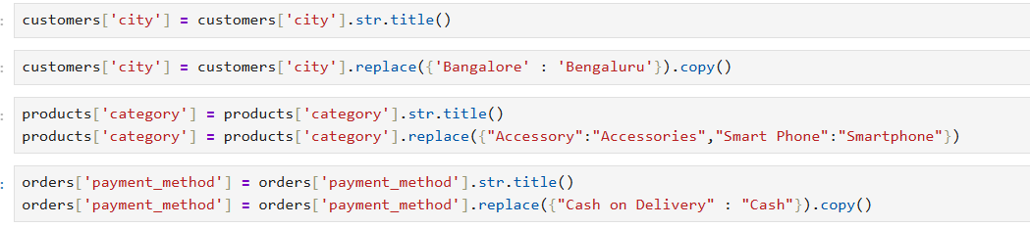
Observation:
- The city column in the customer table has inconsistent values which is replace by the new values.
- The replace and str title function is use to handle the inconsistent values.
- The payment method in the orders table has only one value to replace.

- Handle the missing values

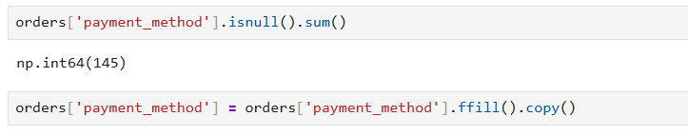
Observation:
- The null values in the payment method column is fill by the forward fill method.
- Forward fill replaces missing values with the previous non-missing value.

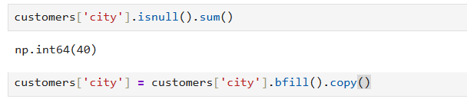
Observation:
- The city column in customer table has null values is fill by backward fill method.
- Backward fill replaces the missing values with next valid observation in data sequences.
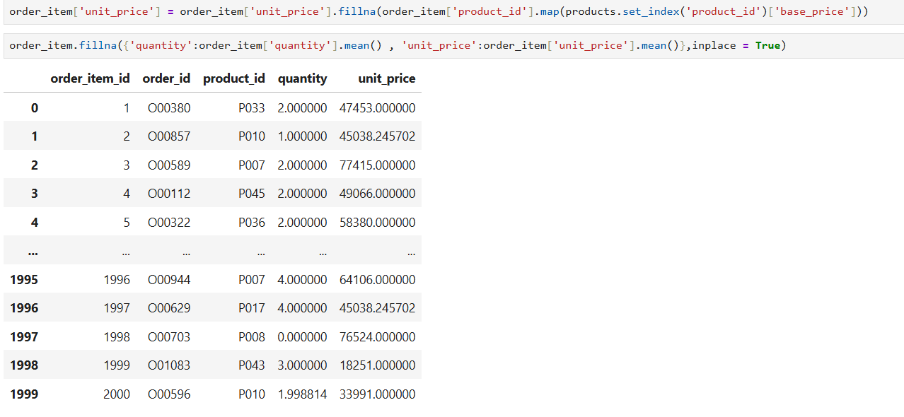
Observation:
- The null values in the unit price column is fill by maping it with base price column in products table.

- The remaining null values in the quantity and unit price column is filled by mean of their columns.
- Merging data
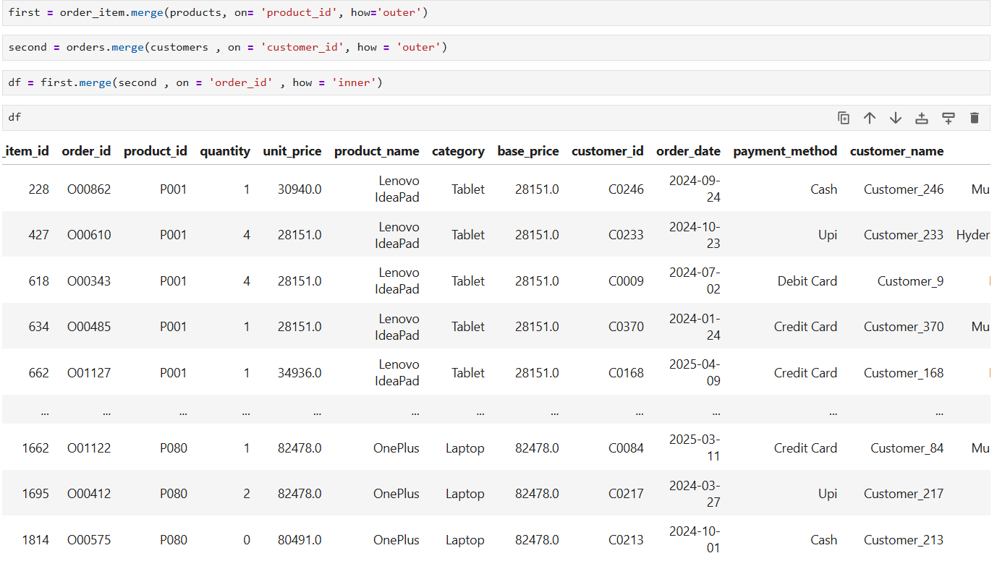
Observation:
- The merging function is used to merge the all 4 tables into a single table.
- The inner join returns only matching rows from the given tables.

- Transforming data / Featuring Engineering
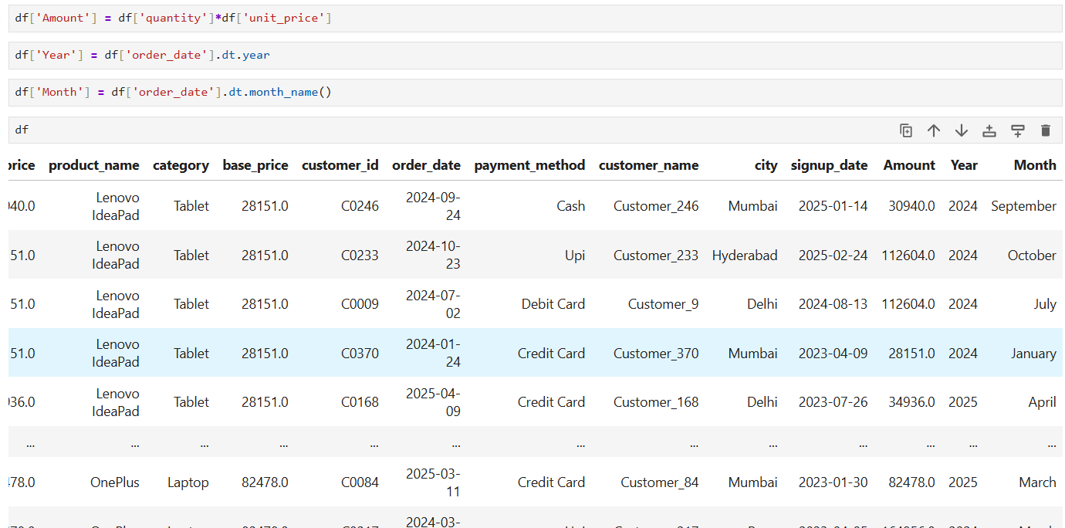
Observation:
- The Amount column is added in the data by multiplying the quantity column with unit price column.
- From the order date column the year and month is extract for better analysis.
- Exploring Data & Visualization

- The Total revenue of each month in the data
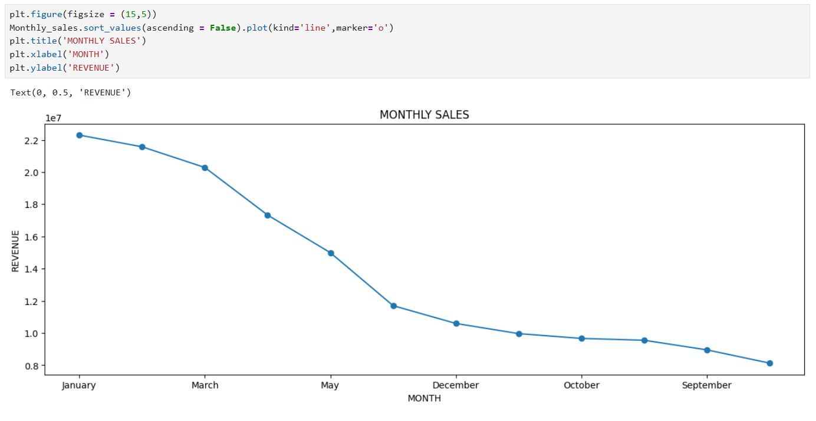
Observation:
  - The line chart is used to visualize the monthly sales trend over time, making it easier to identify increases, decreases, and overall patterns in revenue across different months.
  - The January month has the highest sales and August month has the lowest.

- The Total revenue of top 5 products in data
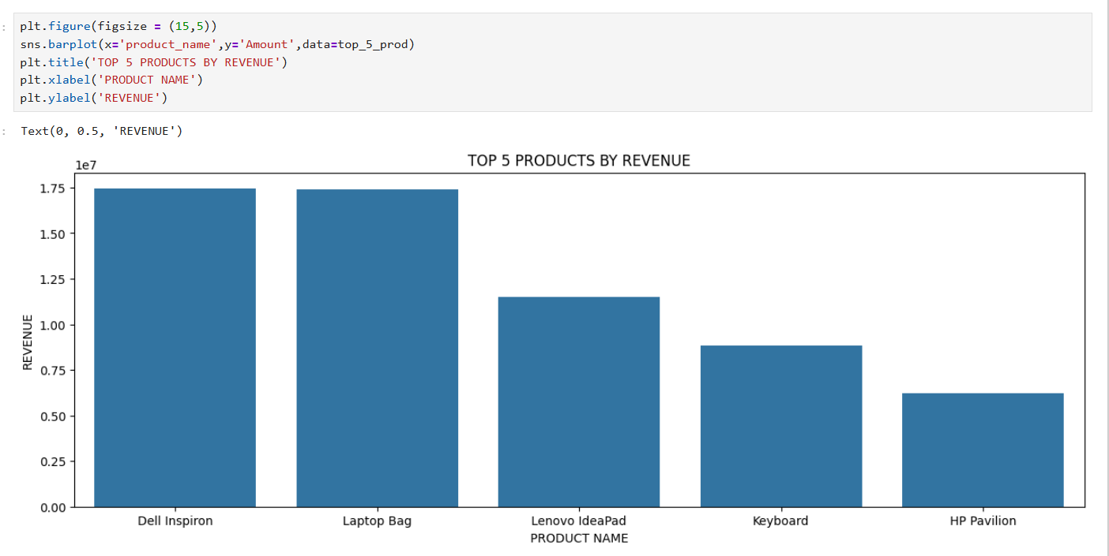
Observation:
- The chart makes it easier to analysis sales trends and understand which products contribute most to overall revenue.
- From the graph, Dell Inspiron and Laptop Bag generate the highest revenue, whereas HP Pavilion contributes the least among the top 5 products.

- The Revenue of the top 5 customer in data

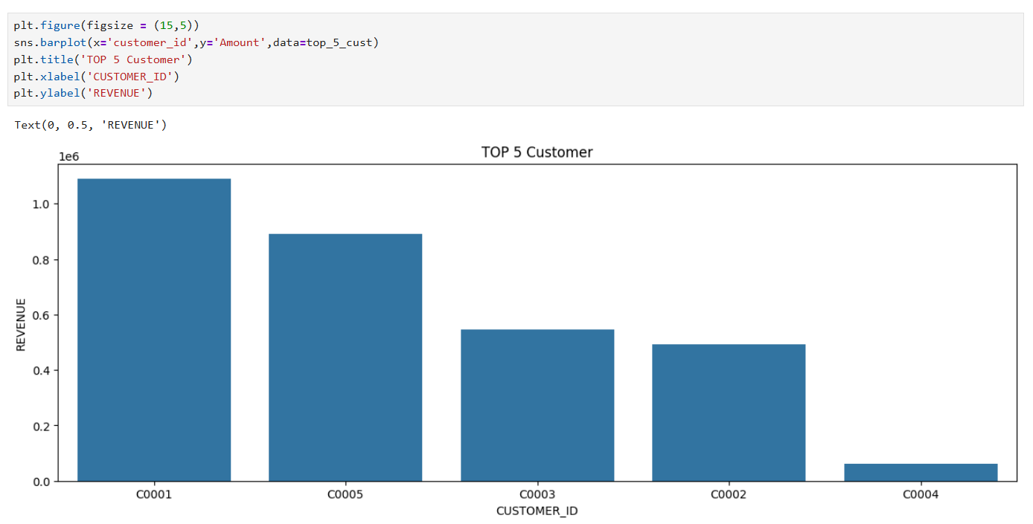

Observation: Customer C0001 generated the highest revenue, contributing around 1.08 million, making it the top-performing customer.

- The top-performing cities on the basis of their revenues
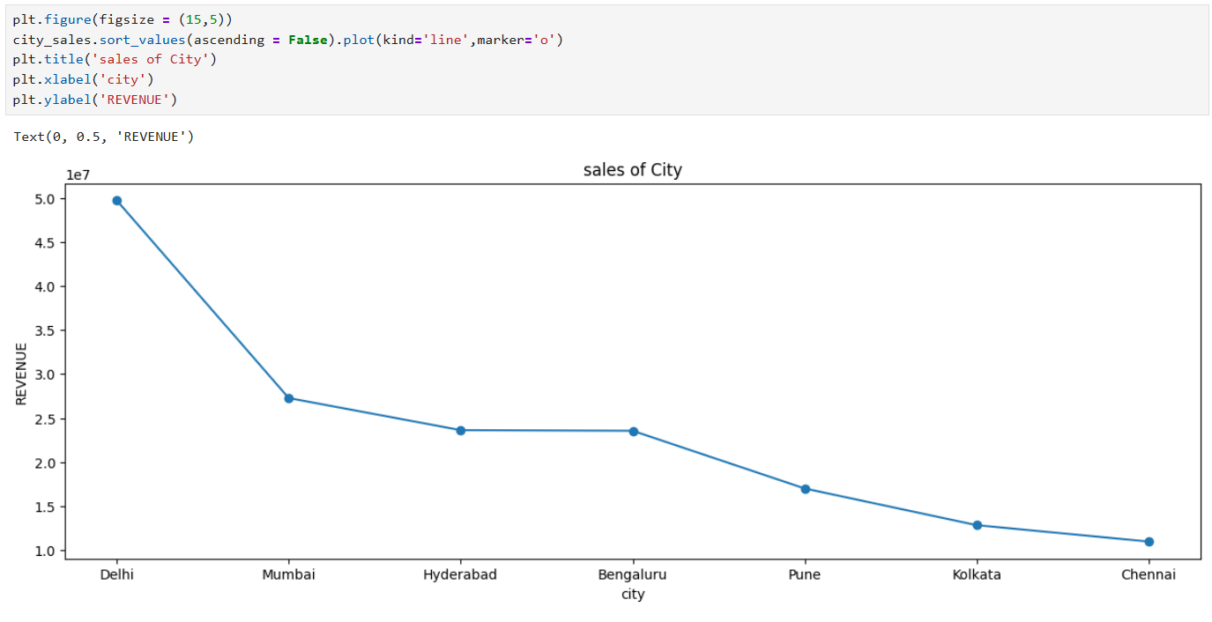

Observation:
- The chart shows overall downward trend in the revenue across cities from Delhi to Chennai.
- The city Delhi has the highest revenue among all the others city.

- The Total quantity sold in each month in the data
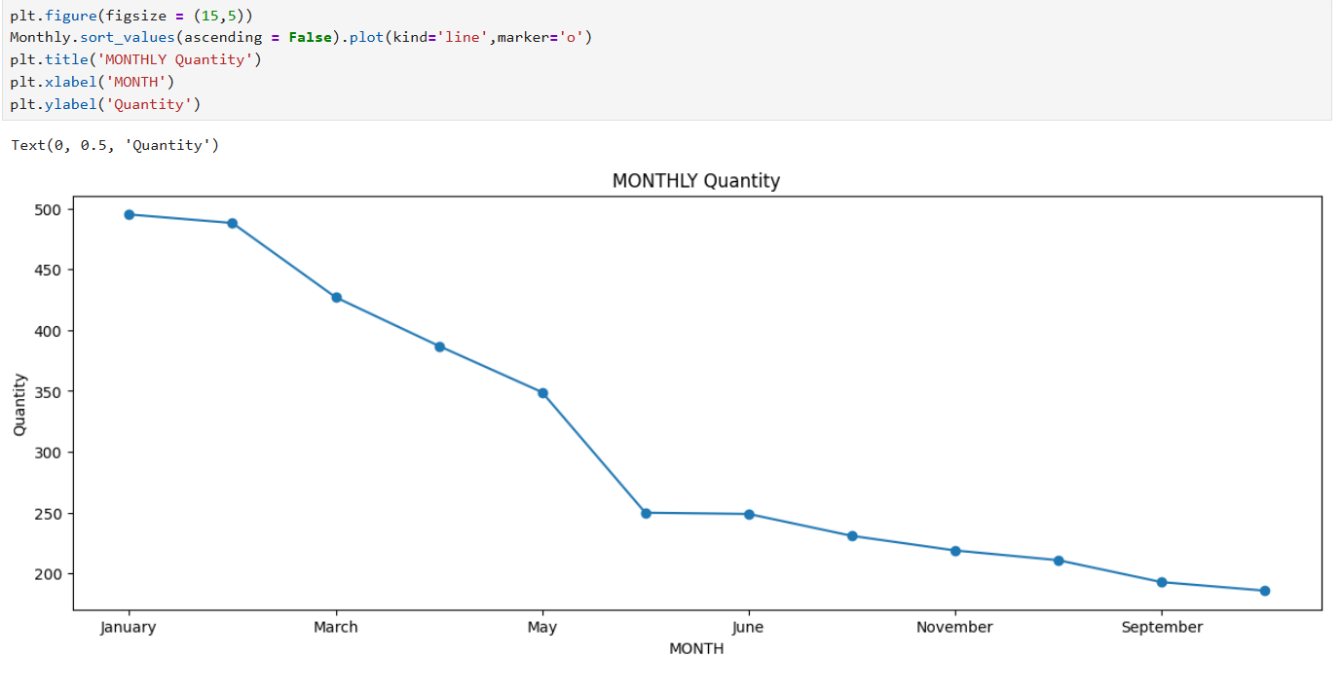

Observation:
  - The line chart is used to visualize the monthly trend over time, making it easier to identify increases, decreases, and overall patterns in quantity sold across different months.
  - The chart suggest that product quantity sold decreased consistently from the beginning to the end of the year.

- The top 5 most demanded products by the customers
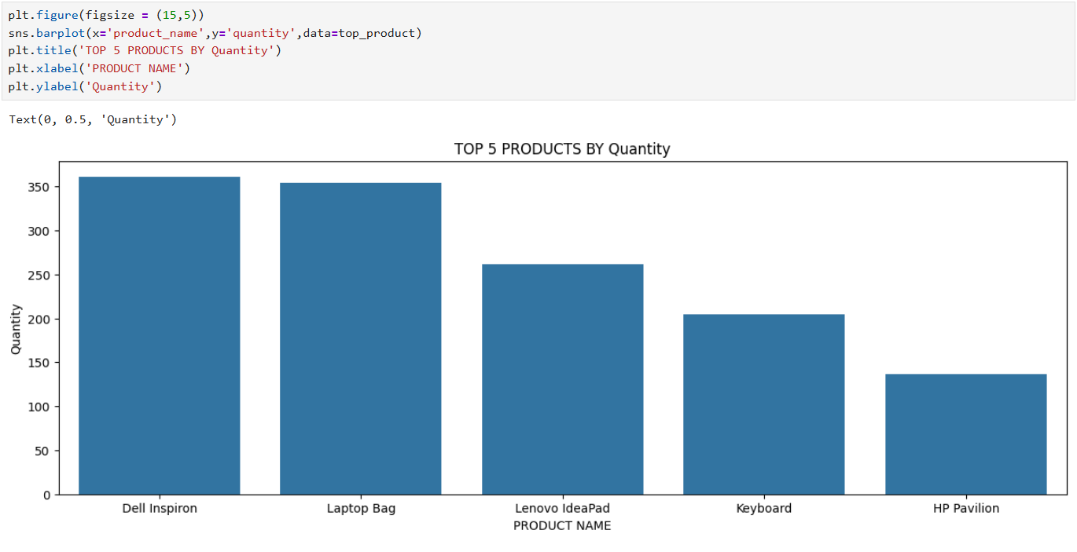
Observation: Dell Inspiron has the highest quantity sold, with around 360 units, making it the most in-demand product.

- The Total quantity sold in each year
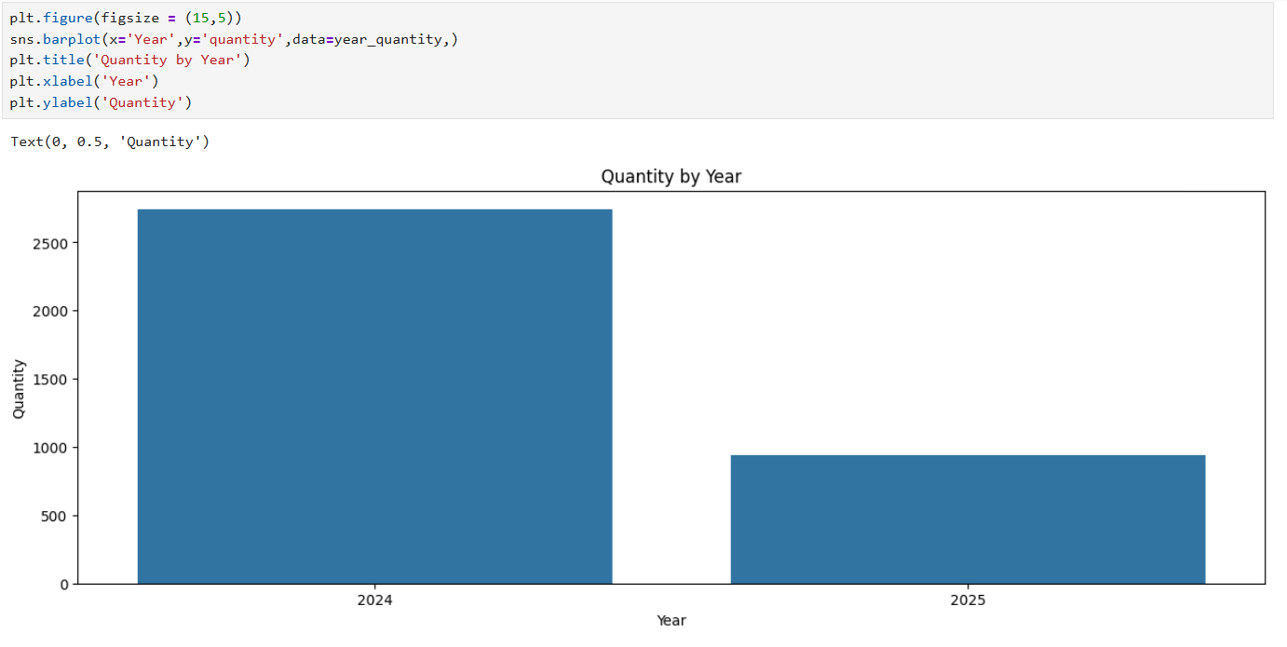
Observation: The quantity in 2024 is significantly higher than in 2025, showing that most sales/orders occurred in 2024.

- The Top 5 cities based on their quantity sold
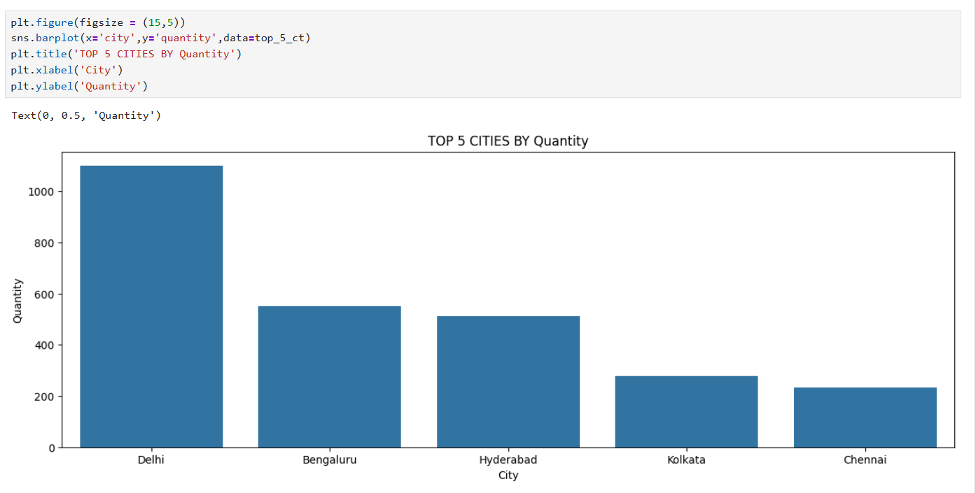
Observation: There is a significant gap between Delhi and the other cities, suggesting that Delhi contributes nearly double the quantity of Bengaluru and Hyderabad.

- This Heatmap shows the numeric columns correlation to find relation between columns.
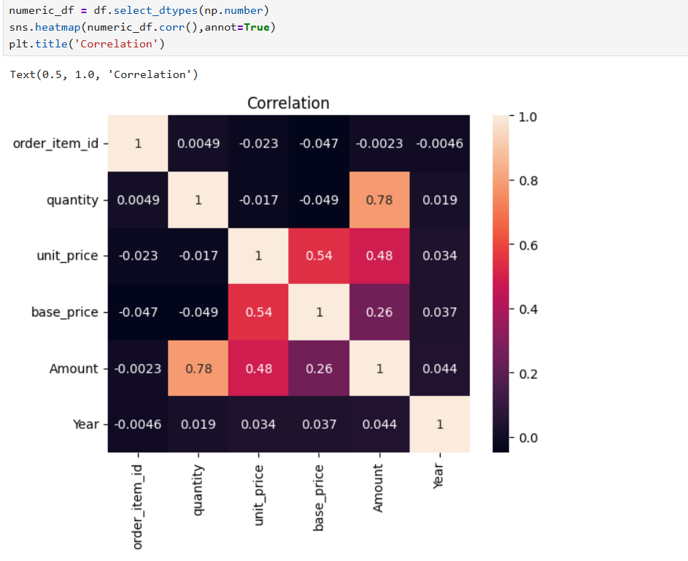
Observation:
- Quantity and Amount show a high positive correlation (0.78), this means when the quantity increases, the total amount also increases significantly.

- Unit Price and Base Price have a moderate positive correlation (0.54), suggesting that products with higher base prices generally also have higher selling prices.

- Small negative correlations such as between Quantity and Base Price (-0.049) indicate that higher-priced items may be bought slightly less often, but the effect is extremely weak.

Key Insights:
- The month January has contributed a major part in revenue and quantity sold.

- The product Dell Inspiron is the top performing among all the other products.

- Most part of the sales and quantity sold are take place in Delhi.

- The correlation graph help the business to understand the relation between the data.
Tools & Technologies used:
- Jupyter Notebook

- Python 3.x

- Pandas: Structured data analysis, data cleaning, filtering, and data frame manipulation.

- NumPy: High-performance mathematical operations and multi-dimensional array processing.

- Matplotlib: Core library for creating static, publication-quality 2D plots.

- Seaborn: Advanced statistical data visualization built on top of Matplotlib.

Conclusion
The analysis revealed important business insights regarding sales performance, customer behaviour, product demand, and city-wise contributions. January emerged as the highest revenue-generating month, while Dell Inspiron was identified as the top-performing product in both revenue and quantity sold. Delhi contributed the highest sales volume and quantity among all cities, and a small group of customers generated a significant share of total revenue. Correlation analysis further showed a strong positive relationship between product quantity and revenue, indicating that higher sales volumes directly drive business growth.

